
Python Installation Steps

For Deep Quant Finance using Python, we will use Anaconda IDE. Uninstall older version of already present in your system. Follow the instructions below.

Step 1 – Go to this url and click ‘Download’
https://www.anaconda.com/products/individual
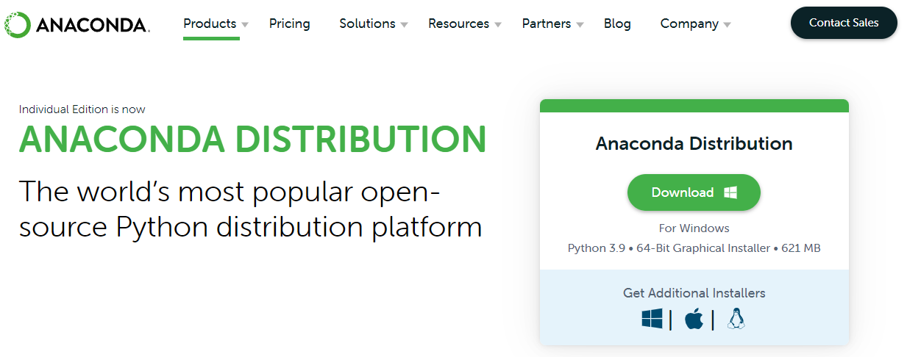

Step 2 – Download the correct installer based on your operating system and 32 bit/64 bit
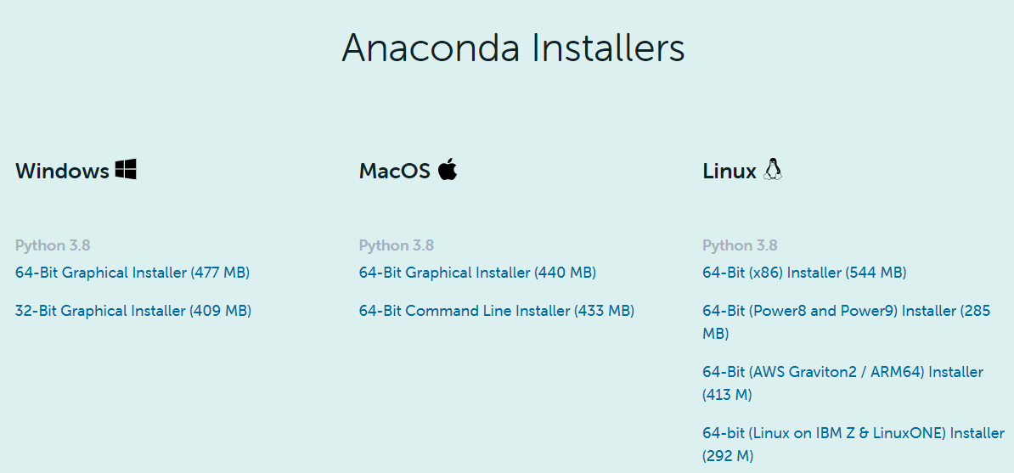
Step 3 – Wait for the download to get complete. Then Click on it to begin installation.

Step 4 – Click ‘Next’ until you complete installation
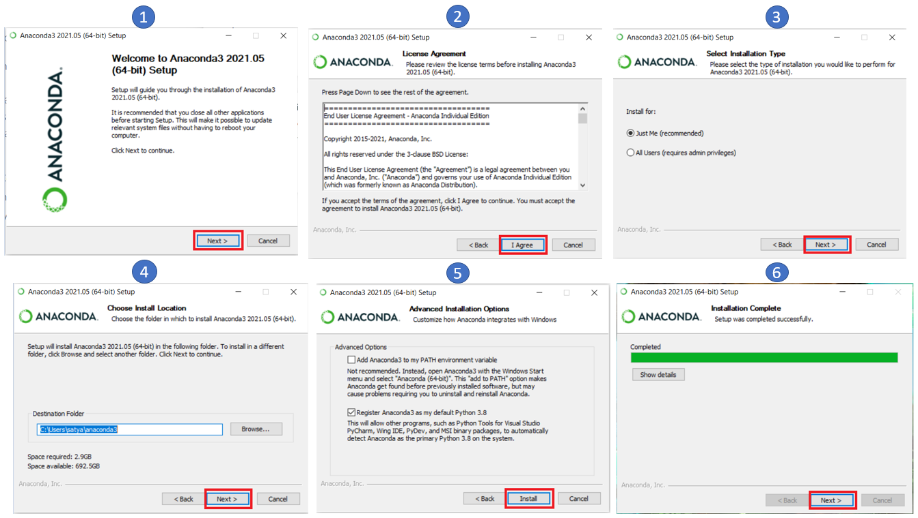

Step 5 – Finish set up
(PyCharm installation is Optional) ( Click ‘Finish’ to complete set up)
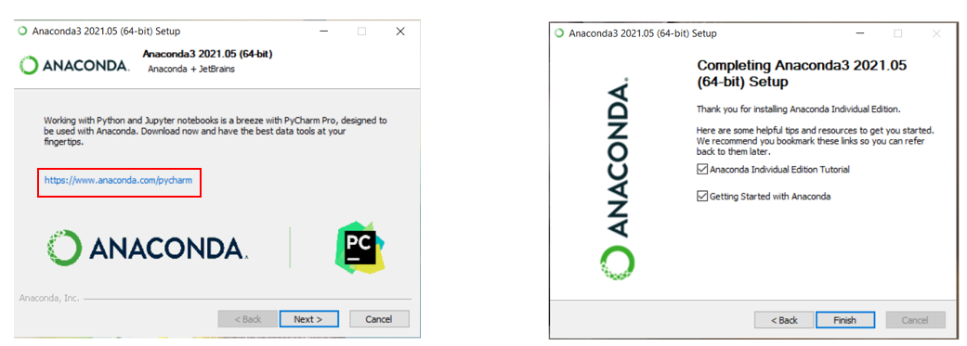

Step 6 – Post Installation, type ‘Anaconda’ in System search bar. You should see the following. We will use ‘Jupyter Notebook’ for our classes
